Hail to thee of might and valor.

I, a lowly servant of Barovia, send honor to thee. We plead for thy to desperatedly needed assistance.

The love of my life, Ireena Kolyana, has been afflicted by an evil so deadly that even the good people of our village cannot protect her. She languishes from her wound, and I would have her saved from this menace.

There is much wealth in this community. I offer all that might be had to thee and thy fellows if thou shalt but answer my desperate plea.

Come quickly, for her time is at hand! All that I have shall be thine!

Kolyan Indirovich

Burgomaster

My friends,

Know that it is I who have brought you to this land, my home and know that I alone can release you from it. I bid you dine at my castle so that we can meet in civilized surroundings. Your passage here will be a safe one. I await your arrival.

Your host,

Strahd von Zarovich

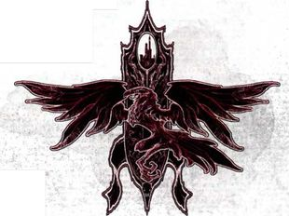

Hail thee of might and valor,

I, the burgomaster of Barovia, send you honor with despair.

My adopted daughter, the fair Ireena kolyana, has been these past nights bitten by a vampyr. For over four hundred years this creature has drained the life blood of my people. How, my dear Ireena languishes and dies from an unholy wound caused by this beast. He has become too powerful to conquer.

So I say to you, give us up for dead and encircle this land with the symbols of good. Let holy men call upon their power that the devil may be contained within the walls of weeping Barovia. Leave our sorrows to our graves, and save the world from this evil fate of ours.

There is much wealth entrapped in this community. Return for your reward after we are all departed for a better life.

Kolyan Indirovich

BurgoMaster